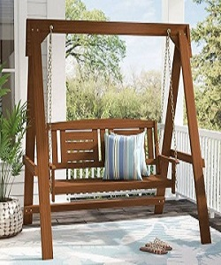

Swing

$98.03

Availability: In stock

Description:

Classic look and Wood frame fits in any style of garden, and backyard. Sturdy base ensure stability, high quality material make it better safety with a smooth rocking motion. The varnish give UV and sunlight protection as well as weather resistant.